Mini Project: Project Ideation

Name: _Agung Yuda pratama Cohort: BDSE07-UIF

1. Understand the overview of the Community Portal from Project Mentor.

|  |  |  |
| --- | --- | --- |
| No | Questions | Answers |
| 1 | What is your purpose in using this community portal? | For looking at some jobs offering and company’s information. |
| 2 | What features do you want on this community portal? | Readily accessible contact and location, fresh and quality content, have a light mode also dark mode. |
| 3 | Who is the target market of this portal? | Software Programmer and Administrator. |
| 4 | What do you think of the user profile's design? | It has a simple UI and Does not have too many animations. |
| 5 | How does the flow if the user wants to register? | Full name, city, country, and date of birth are required. |
| 6 | What kind of portal visit would be excellent for the user? | Easy to navigate, Well Designed and Functional, and always have fresh content. |
| 7 | Can users find information about companies and work opportunities? | It can so the user can easily find the information that they need. |

1. Persona

List the different personas who will be using the Community Portal, with brief description of each of the personas.

|  |  |  |
| --- | --- | --- |
| No | Persona | Brief Description |
|  | Albert Wesker | Albert wants to know about the information of IT companies. |
|  | Ashley Graham | Ashley wants to advance her knowledge about the Administrator. |
|  | Claire Redfield | Claire is looking for his first job experience. |
|  | Karl Heisenberg | Karl searches for high-income jobs in IT Industry. |

1. Create a Personas profile with Demographics, Behaviors & Beliefs, Characteristics & Goals for 2 Personas defined.

|  |  |
| --- | --- |
| Persona (1): | Karl Heisenberg |
| Demographics: | * Age : 32 Years * Nationality : Germany * Gender : Male * Job : Full Stack Developer ( 7 years experience ) |
| Behaviors and Beliefs: | * IT Enthusiast * Have a dream of making self-company |
| Characteristics: | * Ambitious Person * Fast Critical Thinking |
| Goals: | * Got a suitable job for him * Have self-company |

|  |  |
| --- | --- |
| Persona (2): | Claire Redfield |
| Demographics: | * Age : 25 Years * Nationality : America * Gender : Female * Job : Fresh Graduate with a Bachelor of Computer Science |
| Behaviors and Beliefs: | * Easy to adapt to the new environment * Really like to multitask when doing some activity |
| Characteristics: | * Cheerful Person * Fast Learner |
| Goals: | * Have the first job in IT Industry * Make a new team for software development |

1. Conduct Ideation for the Project Scenario and come up with 2 Ideas to meet the Project Scenario

Scenario Name: User Registration

|  |  |
| --- | --- |
| No | Ideas |
| 1 | Karl is interested in looking job in the community portal. So he goes to the website. After that, click the registration button on the top right web pages. In the registration form, Karl must fulfill his full name, date of birth, gender, nationality, email, and password. After he is done, he can click agree and join button. |
| 2 | Karl wants to move from his old job. So, he goes to the community portal and must create a new account to look for job opportunities. After landing on page Karl, click the button Join Us. Karl must fill email, password, last position, and type of employment. Then click the register button at the bottom. |

1. Create Scenario & Storyboard for one of the Scenarios

Intro : 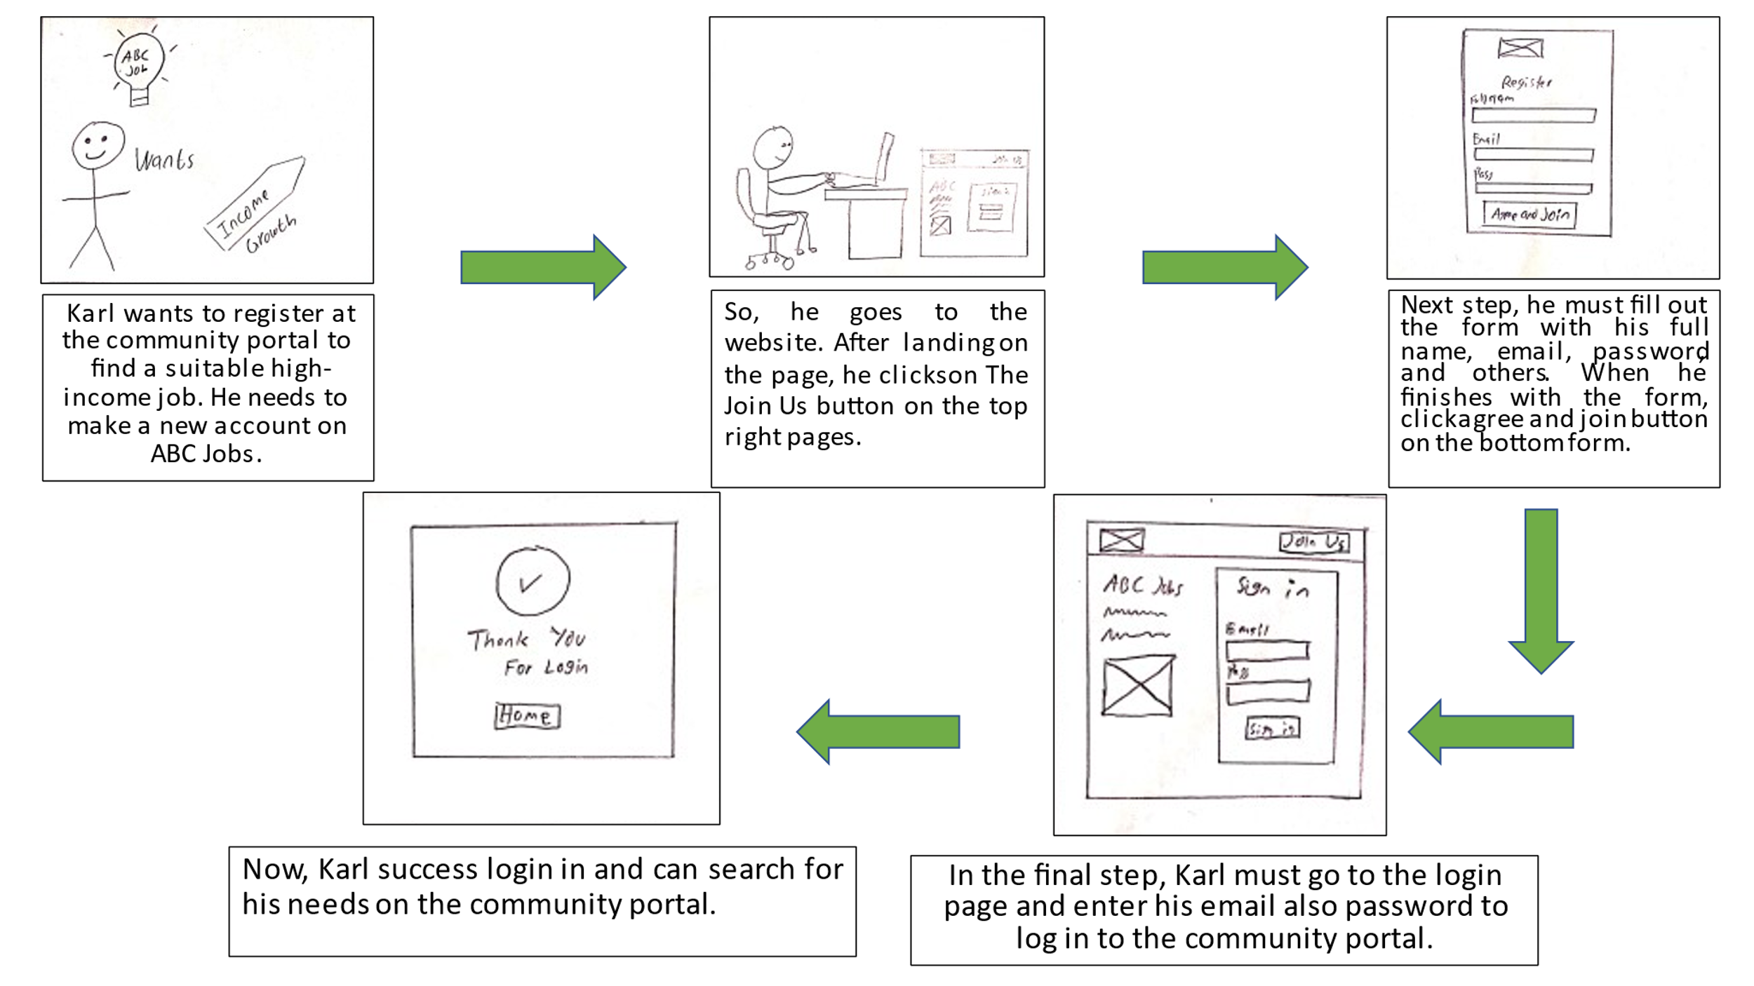

1. Use Axure to Create a Wireframe Prototype for 1 Scenario

Scenario Name: User Registration Form

|  |  |
| --- | --- |
| Wireframe pages | Specifications (Widget Table) |
|  | |  |  |  | | --- | --- | --- | | No | Name | Note | | 1 | Company Logo | Logo of ABC Jobs Pte. Ltd. | | 2 | Join Us | Button for registration. | | 3 | Company Name | Show the Company name. | | 4 | Greetings | Some greetings to the user. | | 5 | Decorative Image | To beautify the website. | | 6 | Sign Form | Form for signing to the website | | 7 | Footer | Reserved for copyright statement | | 8 | Company Logo | Logo of ABC Jobs Pte. Ltd. | | 9 | Note | Just a note for the user to join. | | 10 | Register Form | Form for register to the website. | |
|  |

7. Plan the Implementation for the Project Scenario

|  |  |
| --- | --- |
| Priorities | Scenario |
| Top | 1. Community Portal Home Page  2. Registration Page  3. Registration Confirmation Page  4. Update the Profile Page  5. Search Users Page  6. List Search Results  7. Public Profile Page  8. Registration Confirmation Email  9. Login Page  10. Forget Password Page  11. Design the Forget Password Confirmation Page |